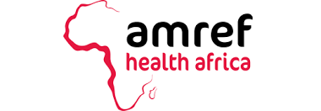 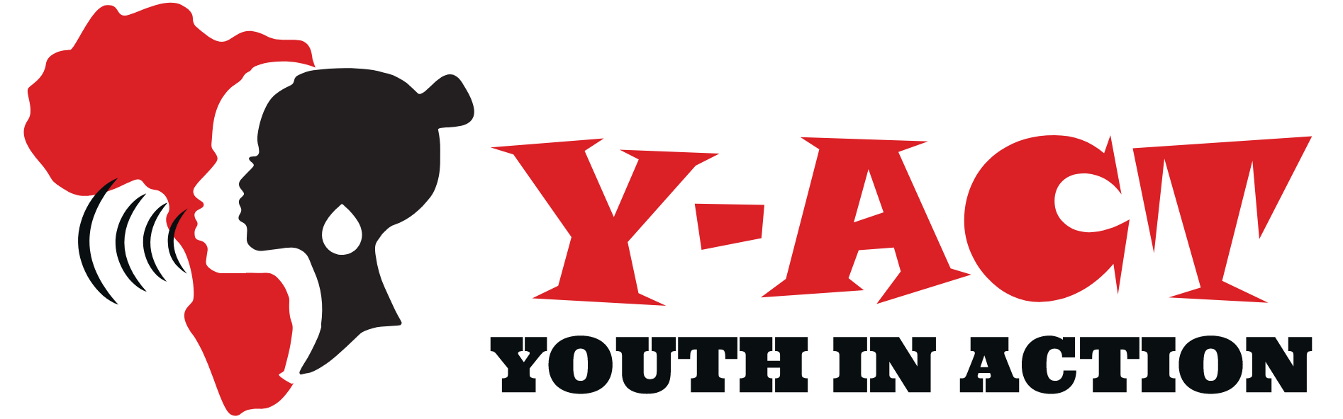

**From Periphery to Center: A Zambian Case Study on Youth-Led Advocacy at the Intersection of Health, Gender, and Climate Vulnerability**

Author: Rebecca Kausa, National Advocacy Coordinator, Amref Health Africa-YACT, Zambia

# 1. Introduction

Zambia is young, over 24% of its population are adolescents, and with a high fertility rate of about 32 births per woman in 2024, we're seeing a real youth bulge. This demographic opportunity of young energy can be powerful but right now, it's also paired with tough challenges: nearly 1 in 3 girls becomes a mother by age 18 (29%) and this rises to around 35% in rural areas. These early pregnancies often result in school dropouts, poor health outcomes, poverty and in times of drought or floods, these pressures just get worse.

# 2. Intersecting Challenges

## Health & SRHR

* Teenage pregnancy is stubbornly high at 29% overall, with rural areas up to 37%, and urban areas about 17%.
* Between 2013 and 2018, the adolescent birth rate dropped slightly from 141 to 135 births per 1,000 girls aged 15–19 but remains concerning.
* HIV among adolescents (15–19) hovered around 3.8% in 2018, with girls at nearly double the rate of boys.

## Gender & Early Marriage

* 31.4% of women aged 20–24 were married before 18; child marriage remains one of the highest in the world.
* In December 2023, Zambia passed a law banning all marriages under age 18, statutory or customary.

## Climate & Environment

* Climate shocks like droughts and floods reduce crop yields, threaten food security, worsen malnutrition, and increase gender-based violence, especially as girls walk longer distances for water.
* Climate variability is estimated to reduce Zambia’s GDP growth by 0.4 percentage points per year, costing billions over time.

**Generation Now: Youth Leadership at the Nexus of Health, Gender, and the Environment**

“Generation Now” shows that today’s youth are ready to lead on the issues that affect them most. In Zambia, young people experience the impact of teenage pregnancy, gender inequality, and climate shocks every day. They know what works in their communities and can take action to make change happen.

Youth bring practical solutions that link health, gender, and the environment. With the right skills in advocacy, research, and policy engagement, they can run campaigns to reduce adolescent pregnancy, push for water points in drought-affected areas, and ensure climate adaptation strategies are included in local development plans.

This generation does not wait for the future. They are leading today. Programs like Y-ACT show that when youth are given space, tools, and support, they can create real, lasting change in their communities. “Generation Now” is about using their energy, knowledge, and creativity to build a stronger, fairer, and more resilient Zambia.

# 3. The Y-ACT Model: Youth as Agents of Change

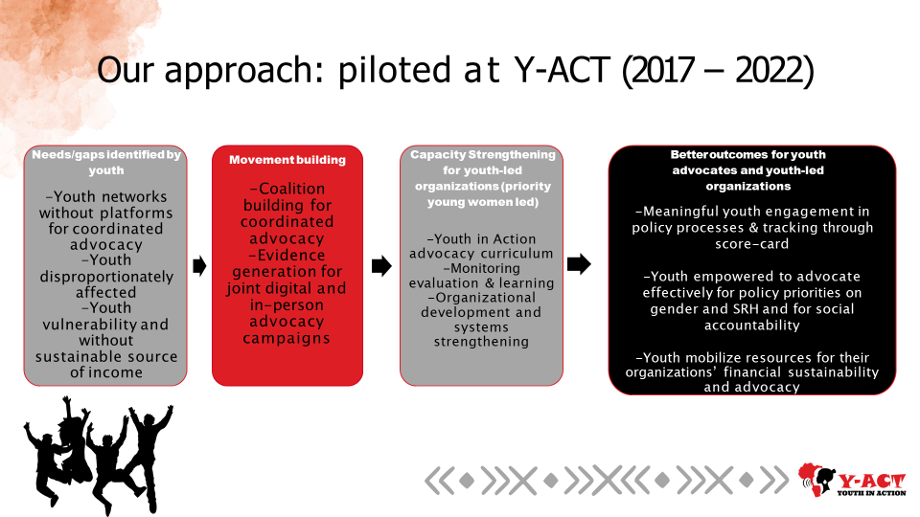

Y-ACT is a movement where youth lead from the front. The model works in three powerful ways:

## 1. Empower

Youth, especially young women, get training in advocacy, policy analysis, and communication. They become confident, informed messengers, ready to speak truth to power.

## 2. Act

Youth lead community projects like pushing for SRHR and climate adaptation to be included in local planning such as new water points, SRHR outreach, or district development plans.

## 3. Amplify

Youth are supported to speak directly with policymakers, traditional leaders, and health officials. Platforms are created so their voices influence decisions, not just echo as token input.  
This is not top-down, it’s youth-led. They research the issues, design the advocacy, and deliver the message.

# 4. Key Insights & Lessons Learned

* Authentic Engagement: Young people must co-own solutions for them to stick.
* Power of Youth Networks: When youth unite across sectors, they move fast and make real change.
* Bridging the Data Gap: Youth-led research brings local evidence into policy conversations, showing, for instance, how adolescent pregnancy rates vary district by district.
* Intergenerational Dialogue: Partnerships with elders, chiefs, health officials turn advocacy into concrete plans and budgets.

# 5. Conclusion & Policy Recommendations

To unlock an equitable demographic transition, we must:

* Invest directly in youth-led groups.
* Create formal spaces for youth in health, climate, and gender policy discussions.
* Integrate policy across sectors, link climate resilience, SRHR, and gender equity at all levels.